Case study 2: How CBP contributed to access to basic essential services by IDPs and vulnerable households: A case of IOM and NRC

The International Organization for Migration (IOM) and Norwegian Refugee Council (NRC) have been supporting the transition of communities from emergency in the immediate aftermath of displacements to early recovery and community stabilization through participatory community driven processes. Both organisations have used Community based planning (CBP) as an entry point for empowering communities to act on the outcome of their planning process. Initiatives identified through the CBP process have been categorised into five domains namely; Food security and nutrition, Natural resources and environment related, Income generating to sustain livelihoods, access to basic essential services and non-tangible or social protection issues. This case study focuses on how CBP enabled IDPs and vulnerable groups to identify and advocate for access to critical basic services required after their displacement.

During the CBP service provision analysis and definition of desired outcomes stage, socio-economic groups including IDPs identified a range of basic essential services that they lack, have access to and need currently and in future. The major desired services included; access to portable safe and clean water for domestic purposes, good hygiene practices and safe disposal of waste, access to good health including reproductive health, maternal and child care, access to shelter, access to quality education to children and improve communication and road infrastructure. The provision of basic social services were provided within the general service delivery framework. NRC had a well-defined Protection Referral Pathway linked to the CBP process where basic social services such as issuing of birth certificates, government assisted agriculture input schemes, reproductive health services, access to education and safe drinking water were provided within the general service delivery framework.
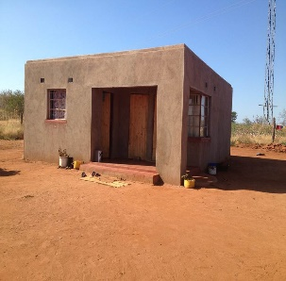
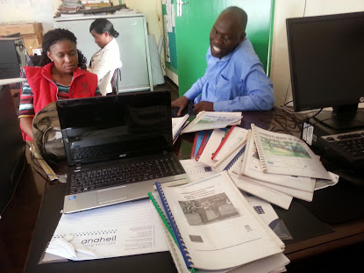
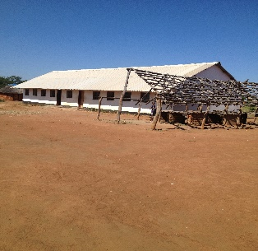
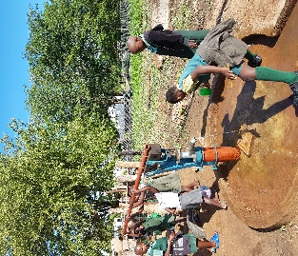
Community Action Plans in Chiredzi District

Area to build IDP houses was provided however resources required to build shelter was exclusively for IDPs and vulnerable households from the host communities as defined in the Community Action plan. The protection and social services promotion included infrastructural developments such as school buildings, clinics and development of water sources such as piped water schemes and boreholes for domestic and productive purposes. In addition, NRC facilitated a Protection Referral Pathway that linked communities to mainstream protection services and other non-governmental protection programmes. These were key interventions that IDPs and host communities have valued. The success on the provision of basic service infrastructure was enabled by Government which provided land, technical expertise and other material resources while local communities contributed locally available resources. This enhanced a sense of ownership and sustainability of the infrastructure that was built.

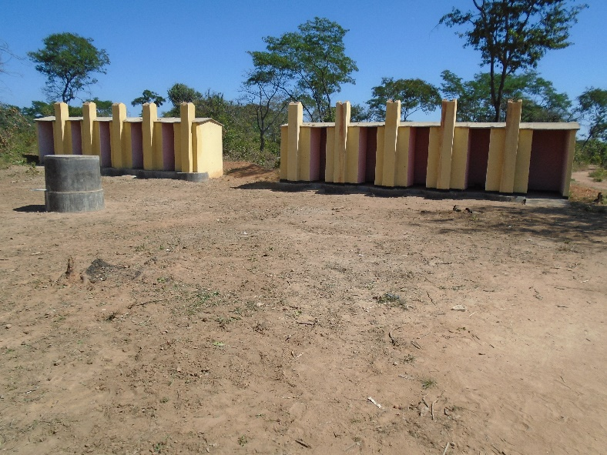
Improved access to healthcare and portable water for the IDPs and their host communities was achieved in partnership with Ministry of Health and Child Welfare through provision of mobile clinic, construction of clinics ( e.g Chabili clinic in Mangwe District is benefiting over 2000 households), staff houses and Water, sanitation and hygiene initiatives (drilling and rehabilitation of boreholes, construction of latrines). At schools, there was construction of 10 squat hole ventilated latrines for the school children and two-hole ventilated toilets for the teachers, establishment boreholes and water storage tanks. minimized healthcare challenges. Although the provision of water through boreholes has improved the access to water, the water sources in displacement affected wards are sparsely distributed and most wards are still experiencing some water stress during the dry period. In resettlement areas where the boreholes provided are the major sources of water, there exists competition for domestic, Low Input Gardens (LIG) and livestock needs which requires management by the community and further investment from other agencies.

Improved access to basic education for the IDP children and those from host communities were made through provision of classroom block, teachers’ house, furniture and reading materials. In Beitbridge District the construction of classroom blocks at Himago Secondary School has contributed to an improved learning environment for over 300 pupils.
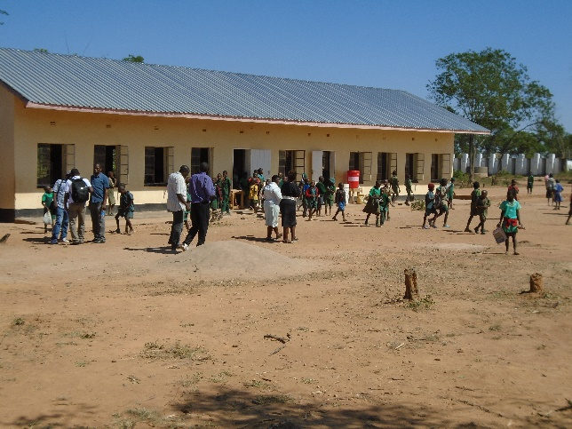

The restoration of housing, land and property was mainly relevant to the people who had been forcefully displaced from their original places of habitation. IOM, worked with local district authorities and the local community in Mugondi, Ward 15 of Chipinge to construct 129 two-roomed houses for the IDPs and another 31 for vulnerable households in the host community. The support package, for every house built also included a matching ventilated latrine.

The establishment of Mazwi Village and the resettlement of the former squatters resulted in tensions with the host communities of the existing villages of Hyde Park, Robert Sinyoka and St. Peters.
“I never dreamt that one day I would have a proper roof over my head and actually own a house. Ours was a life of constant harassments from the police and the Bulawayo City Council as they constantly raided our settlements for demolitions”
Jester Banda, Mazwi village, Khami District.
Banda is one of the 197 former squatters who were resettled at Mazwi village. With the support from SIDA, SDC, OFDA and ECHO, 197 former squatters from Trenance and Killarney were resettled in Mazwi Village. According to Tariro Magura from the Khami District Administrator’s office, the CBP process brought the Killarney and Trenance residents together with host communities to plan for their own development. Through the CBP process, the communities sat down together to identify development priorities that would be driven by them. Due to this planning process, Mazwi Village was born, providing decent shelter, proper sanitation facilities and access to safe water for the 197 beneficiaries.

The IDPs were also issued or regularised their identity documents so that they are not disenfranchised in public affairs issues such as payment of levies and participating in elections.

Community based planning therefore enhanced access to basic services for IDPs and host communities, including education, health, food, livelihoods, WASH, affordable housing and land. Communities who have undertaken the CBP process are now organised to plan and link with relevant support/service providers. This is seen in the inclusion of local voices, representation and ability of communities to plan and link beyond a project or programme.

