Case study 1: THE INCLUSION AND INTEGRATION OF INTERNALLY DISPLACED PERSONS INTO HOST COMMUNITIES IN ZIMBABWE: THE CASE OF MUGONDI

International Organization for Migration Mission in Zimbabwe (IOM) and the Government of Zimbabwe (GoZ) have been working together in promoting early recovery, community stabilization and attainment of durable solutions for internally displaced persons (IDPs). Community Based Planning (CBP) has been used as a tool to foster recognition, acceptance and inclusion of IDPs and other vulnerable groups (such as women, youth, children, female and elderly headed households, people with disabilities and those living with chronic illness) to broaden community participation and ownership of development initiatives within communities. This case demonstrates how CBP was a game changer in harmoniously and peacefully integrating IDPs with host communities. In October 2009, about 342 IDPs were evicted in Gwenzi area, Ward 15 of Chipinge District following a land dispute between small scale farmers and their farm workers. The farm workers were displaced to Muzite Business Centre where they received free emergency assistance in the form of food and 80 standard non-food items package which included emergency 606 shelter materials and 244 hygiene kit from IOM and other Humanitarian partners. Provision of emergencies immediately provided temporary relief and created an opportunity for recovery and stabilisation for the IDPs.

The Chipinge Rural District Council entered into a partnership with IOM to resettle the affected population. The District authorities in Chipinge identified Mugondi area, in the same (Ward 15) for resettlement of IDPs from Muzite Camp. However, the host community in Mugondi area were not in favour of the IDPs being resettled there. They cited differences in ethnic, cultural, religious and political value systems as potential sources of conflict with the IDPs. The host community also viewed the displaced people as creating unplanned pressure on already limited existing resources. With these circumstances, the IDPs felt they had no sufficient sense of security and stability, to confidently engage in that society in a manner consistent with shared notions of neighbourhood and citizenship. During the awareness and buy-in stages of the CBP process, the local authorities, local leadership, host communities and IDPs were engaged in a series of deliberative dialogue to negotiate, search and reach consensus with other socio-economic groups on sustainable and durable solution to the IDP caseload. The engagement process resulted in strengthened cohesion (encouraging positive relationships between different groups). Different stakeholders gave explicit feedback about their understanding of ‘community cohesion’ and integration of IDPs;
The initial stages of the CBP process promoted a sense of commonality between different groups by encouraging trust, respect and positive relationships. The dialogue focused on tangible and real-life issues affecting the IDPs and the host communities in Mugondi area
The Ward Councillor: Ward 15

Discussions that focused on improving the local area and services were effective for building a sense of shared concerns. The key lesson was that communities unite in development initiatives if they are engaged in deliberative dialogue.

During the actual planning process, the host communities and IDPs including other vulnerable socio-economic groups in the Ward were engaged in developing a shared vision and prioritisation of development initiatives. The main product of this process was a ward based development plan endorsed by the Local authorities especially the Rural District Council and the Office of the District Administrator. The process helped the host communities and IDPs to take collective action, accept and become responsible citizens on issues that affect their lives. They planned together and identified their desired outcomes including basic needs and rights, particularly peaceful co-existence, inclusive decision making and access to basic social services.

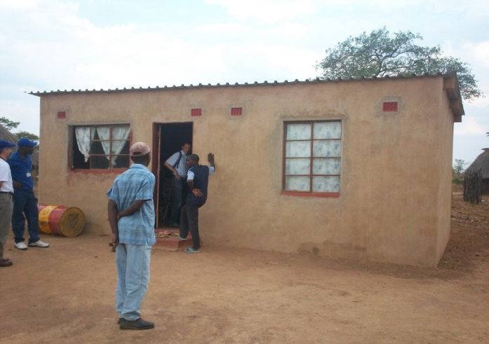
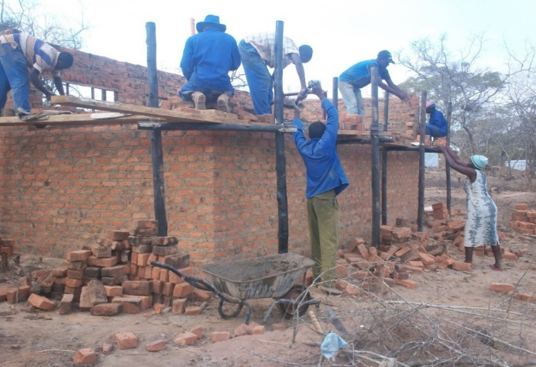
Planning together created an opportunity for both the IDPs and the host communities to engage in dialogue, hear, listen and reach consensus on how to transform their lives in an integrated manner. They also realised that planning together made them create a shared understanding of each other’s vision (not necessarily a common vision) and that they could help each other reach their desired outcomes.
“The CBP process created an opportunity for us (IDPs) and other vulnerable groups to have our voices organised and be treated with the same degree of respect and attention that all Zimbabwean citizens receive especially on enjoying equal access to social services and recovery resources. We are no longer being viewed as trouble makers- vekumatende! or “aliens” but as equal contributing members by the host communities
IDP Secretary Mugondi area
IDP and host community builders working together in shelter construction in Mugondi

Formerly displaced persons were not subjected to discrimination for reasons related to their displacement instead there was evolution of a beneficial relationship and rebuilding of trust. This gradual change of attitude by the host community was facilitated by the fact that IDPs were able to productively contribute to community development projects. A noticeable change was a shift from passivity and waiting mode to IDPs communicating assertively and identifying own potential.

CBP ensured that the needs, vulnerabilities, priorities and aspirations of the whole community, including for those who are socially, politically and economically marginalized (such as IDPs), are incorporated into ward based development and recovery plans. This enabled IDPs and other vulnerable groups’ desired outcomes to be legitimately and transparently incorporated into government endorsed recovery programmes. CBP therefore enhanced capacity of communities to influence resource allocation at both local-, meso and macro levels including recognition of the role of IDPs in public affairs and development planning. The CBP process also created an opportunity for IDPs and other vulnerable groups to decide on the location of the prioritised initiatives taking into considerable security, distance accessibility and utilisation issues. Community projects stemming from the Ward Development Plants and supported through community managed grants, further cemented the cohesion of these communities and strengthened the acceptance of IDPs within the host community.

The IDPs confirmed that the security of tenure certificates issued and the CBP process gave them the enthusiasm to invest in long term livelihood interventions in the areas where they are currently residing. There were however, no certificate of no objection or lease agreements for use of land at some sites which may result in some IDPs losing land in case of a conflict with the previous land owners.

The IDPs and host communities worked side by side in community development activities such as establishment of an irrigation scheme and water source development. The process contributed to acceptance of IDPs by hosts and promoted integration and social cohesion.
Role of IDPs in Committees
As IDPs we were integrated into local community development programmes through participation in community development committees and public affairs. We have some IDPs elected in Project Management Committees, Irrigation Management Committees, Water Point Management Committees, and local governance structures together with the host community
Committee member in Mugondi IMC

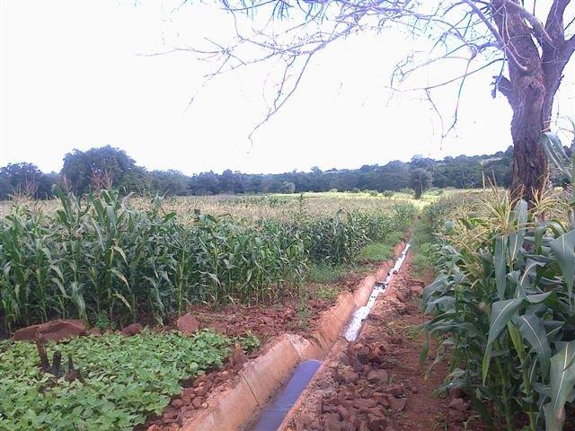
Maize crop under Mugondi irrigation Scheme.
In Mugondi, IDPs have representatives in the Ward Development Committees (WADCOs) and Village Development Committees (VIDCOs). Furthermore, IDPs were integrated into local voters’ role and participated in elections. All IDP households in Mugondi are registered and participate in local and national elections. The community based planning processes enhanced local leadership capacities to lead, facilitate and coordinate inclusive planning and recovery programmes in migration affected areas. Community members in affected areas, including women and youth, were empowered to engage in structured dialogue to analyse their circumstances and conflict triggers; prioritise their needs; establish systems for dispute resolution and peaceful co-existence; and ultimately take ownership for driving their own recovery processes, based on priorities that they identified.
The restoration of housing, land and property for the Mugondi IDPs was mainly also fundamental to the integration process. Through CBP, IOM, working with local district authorities, assisted the local community in constructing 129 two-roomed houses for the IDPs and another 31 for vulnerable households in the host community. Following integration, the IDPs did not experience security threats related to their displacement status against which they would have wanted special protection from host communities. In their new settlements, they enjoy the peaceful and secure environment prevailing for non - IDPs. The process was therefore a useful tool that facilitated integration of IDPs with the host community in a way that minimized the risk of stigmatization. The IDPs feel at peace in their new settlements and they express positive perceptions of their safety and security including land tenure. CBP’s contribution in this regard was creation of cohesion and peaceful integration of the IDPs into their host and surrounding communities.

